Λογότυπου του έργου 4PLUS
Πρόγραμμα Interreg IPA II CBC
Greece–Albania

How can we help people with disabilities when a threat occurs?

**A life may depend on you**

|  |  |  |  |
| --- | --- | --- | --- |
|  |  |  |  |
| EARTHQUAKE | FIRE | FLOOD | EXTREME PHENOMENA |

The 4PLUS project is co-funded by the European Union and National Funds of the countries   
participating in the Interreg IPA Cross-Border Cooperation Programme “Greece-Albania 2014-2020"

**National Confederation of Disabled Persons (NCDP)**

Headquarters: 236 El. Venizelou str., P.C. 163 41, Ilioupoli

Tel. +30 210 9949837, Fax +30 210 5238967

E-mail: esaea@otenet.gr, Website: [www.esamea.gr](http://www.esamea.gr)

② The page of NCDP in Facebook: <https://el-gr.facebook.com/ESAmeAgr>

① Follow NCDP on Twitter: <https://twitter.com/ESAMEAgr>

 Find the NCDP channel on YouTube: [www.youtube.com/user/ESAmeAGr](https://www.youtube.com/user/ESAmeAGr)

Athens, 2021

This guide was prepared for the NCDP from the company EUROPRAXIS μ.IKE. in the framework of the project "4PLUS: Public awareness, Preparedness, Participation and Coordination for Civil Protection for All". The project is part of the "Interreg IPA II Cross-Border Cooperation Program Greece-Albania 2014-2020" (greece-albania.eu) and is co-financed by the European Union and by national funds of Greece and Albania. The views expressed in the guide do not necessarily reflect the views of the European Union, the participating countries and the Managing Authority.

Editing and production  
of alternative accessible formats:

**EUROPRAXIS μ.ΙΚΕ**

*4 Vergas str., P.C. 176 73 Kalithea*

Tel.: +30 210 9521313, Fax: +30 210 9521318

e-mail: [info@euro-praxis.com](mailto:info@euro-praxis.com)

Website: [www.euro-praxis.com](http://www.euro-praxis.com)

# What is the issue?

Large-scale natural disasters, such as fires, severe weather events, floods and earthquakes, are largely unpredictable and endanger many aspects of people's lives - health, safety, security, housing, access to food, water and other basic necessities, to name just a few. Various studies from around the world have now shown that in disasters of any typology, people with disabilities are at greatest risk and **are** **disproportionately affected** compared to the rest of the population. The same applies to many elderly people, people with increased nursing needs and in general to all people with reduced mobility and/or autonomy, whether temporary or permanent.

The issue of preparedness is a shared responsibility. It concerns us all. It is clearly about the preparedness of state mechanisms and operational teams, but it is also **about the preparedness of individuals and their families**. It is also about the preparedness of friends, neighbors and the whole population in general, since at some point everyone may find themselves in the position of being the only person nearby who can help.

# How do we help when a threat occurs?

This section outlines what each of us can do and what we will need to know so to best assist various vulnerable people with disabilities at the time of a threat.

## People with mobility-related limitations

Mobility limitations may make it difficult for a person to use stairs or move quickly over long distances. Limitations may include reliance on mobility equipment such as a wheelchair, walker, crutches or cane. People with a heart condition or breathing difficulties may also have limited mobility.

**Some practical guidelines-advice:**

* If possible, use latex-free gloves when providing personal care
* Try to ensure that the person's wheelchair is carried with the person
* If this is not possible, use other evacuation techniques as appropriate, such as:
  + the use of an evacuation wheelchair
  + the creation of a shelter in place (if such an official instruction has been given)
  + lifting and transport by trained personnel
* Do not push or pull a person's wheelchair without their permission unless it is a matter of life or death

## People with hearing-related limitations

The way emergency warnings are issued in the event of an emergency may not allow people with hearing loss to perceive the danger, understand the instructions and/or respond for their own safety.

**Some practical guidelines-advice:**

* Try to inform the person of the danger/situation. If you can stay together until the danger is over.
* Get the person's attention with a visual cue or a gentle touch on their hand
* Do not approach the person from behind
* Stand in front of the person, make eye contact when talking to them as they can rely on lip reading and communicate at close range
* Speak clearly and naturally
* Do not shout or speak unnaturally slowly
* Try to rephrase, rather than repeating
* Use gestures to clarify your meaning
* If there is time, it might be helpful to write a message
* Hearing aids amplify sounds and can cause physical shock to the wearer, so do not make loud noises
* Note that some people may be deafblind

## People with vision-related limitations

A person who is blind or has impaired vision may have difficulty reading signs or moving around in unfamiliar surroundings during an emergency. They may feel lost and/or dependent on others for guidance.

**Some practical guidelines-advice:**

* For people who are deaf-blind, draw an "X" on their back with your finger to let them know you can help them
* To communicate with someone who is deaf-blind, trace the letters on their hand with your finger
* To lead a person, stay half a step ahead, give them your hand and walk at their pace
* Do not shout at a person who is blind or visually impaired
* Speak clearly and give specific instructions
* Provide advance warning of upcoming stairs, large obstacles or changes in direction
* Watch out for obstacles (e.g., at head height) that the person could hit
* Never grab a person with vision loss unless it is a matter of life or death
* Do not assume the person cannot see you
* Avoid 'there' type directions and describe locations such as 'to the right / left / straight ahead / behind you' or using clock face positions (i.e., exit is at 12 o'clock)
* If the person has a service animal on duty, ask them where you should walk to avoid distracting the animal
* Do not separate the animal from its owner - Plan the evacuation of the dog together with the owner
* Do not pet or feed the animal without the owner's permission
* In case you are asked to pick up the dog while helping the person, it is recommended that you hold the leash and not the dog handle

## People with invisible disabilities

People with invisible disabilities may have difficulty performing certain tasks, even though their condition is not obvious. Non-visible disabilities may include communication, cognitive, sensory, mental health, learning or intellectual disabilities that may impair a person's response to an emergency. Conditions may include allergies, epilepsy, diabetes, lung or heart disease and/or dialysis dependency, different supplies, etc.

**Some practical guidelines-advice:**

* Allow the person to describe the help he or she need
* Find effective ways to communicate, such as planned or written directions, using landmarks instead of general terms like "go left" or "turn right"
* Maintain eye contact when talking to the person
* Repeat the instructions (if necessary)
* If a person needs to take medication, ask if they need help getting/receiving it
* Never offer medicines that have not been prescribed by a doctor

## Elderly people

The elderly people, especially those with medical conditions and/or limitations, may be confused and may need directions and/or assistance in an emergency.

**Some practical guidelines-advice:**

* Check the neighbors to find out if there are elderly people who would need your help in an emergency
* Allow the person to describe the help they need
* Always speak calmly and make sure you are there to help
* Avoid shouting or speaking unnaturally slowly
* Know the location of emergency buttons (some buildings have emergency buttons located in bedrooms and toilets)
* Follow the instructions that come with special needs equipment and/or assistive devices

## People in multi-storey buildings

Several people in your building may be confused and need your help when a hazard occurs.

**Some practical guidelines-advice:**

* Check in on neighbors and/or colleagues with disabilities to see if they need your help
* Offer to carry the person's emergency kit along with any special equipment
* Avoid attempting to lift, support or assist someone up or down the stairs unless you are familiar with safe techniques, and do not enter/put the person in lifts in the event of fire/smoke and whenever there is a risk of electricity power failure.

# How we can help people with disabilities improve their preparedness in advance

According to the World Health Organization, for a population, the **risk**, i.e. the probability of harmful consequences (death, injury, loss/damage to property, etc.), from the occurrence of potential disasters, is proportional to the **magnitude of the threat** (i.e. the intensity of the phenomenon) to which the population is exposed and the **vulnerabilities** (e.g., the degree of vulnerability) of that population, but inversely proportional to its level of **preparedness**. Therefore, especially for populations with increased vulnerabilities (vulnerable populations such as people with disabilities and/or chronic conditions), improving emergency preparedness, i.e., the ability to respond, is a critical factor and requires advance **planning** and **expertise**. By taking a few simple, but targeted, steps today, a person can be better prepared to deal with a range of emergencies. This is something we can all help with.

For example, one of the measures recommended for those with disabilities (people with disabilities and/or chronic conditions, elderly people, etc.) to maximize their levels of preparedness is to build their **personal support network** with those who are necessary and willing to help in an emergency. Members of a person's personal network can be from their immediate environment (family, friends, work) or from wherever the person spends a lot of time and who will be able, if required, within a short time during the event of a threat but also afterwards, to support the person. In addition to family, neighbors and partners who are often the closest and most available contacts in an emergency, a person's personal network should include any personal carers and/or doctors, as well as some contacts from their local disability association, from voluntary rescue organizations in their area and/or community services of their municipality.

Therefore, check with your neighbors, your colleagues and generally everyone who is close to you in one way or another and who will need additional help to prepare for emergencies and also to deal with them more effectively. Discuss and agree that you are willing to help and in what way. You should find out what the person's particular needs are and how they will be able to leave their home or workplace, what medicines they are taking and what assistive equipment they use.

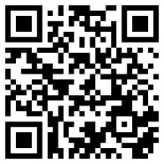Discuss where to look for the person in case of emergency and develop with him/her their **personal emergency plan**. The person may want to give you copies of important documents and/or a key to their home and let you know where they keep their **supplies and emergency backpack**. If necessary, help the person to prepare a list of their personal network contacts, and also a list of other important phones and contacts in their area and keep a copy for you which you should store appropriately, e.g., on your electronic devices. Agree on how you will be contacted and pre-determine possible safe meeting points, in case of evacuation, for on-site shelter and also for after the disaster. Be sure to confirm your agreed-upon ways of communicating at regular intervals and keep each other informed of changes in each other's schedules, as well as periods of time someone will be out of town.

Additional information

Visit our portal at **https://portal.4plus-project.eu** and learn more about the civil protection of people with disabilities and people with reduced autonomy in general.

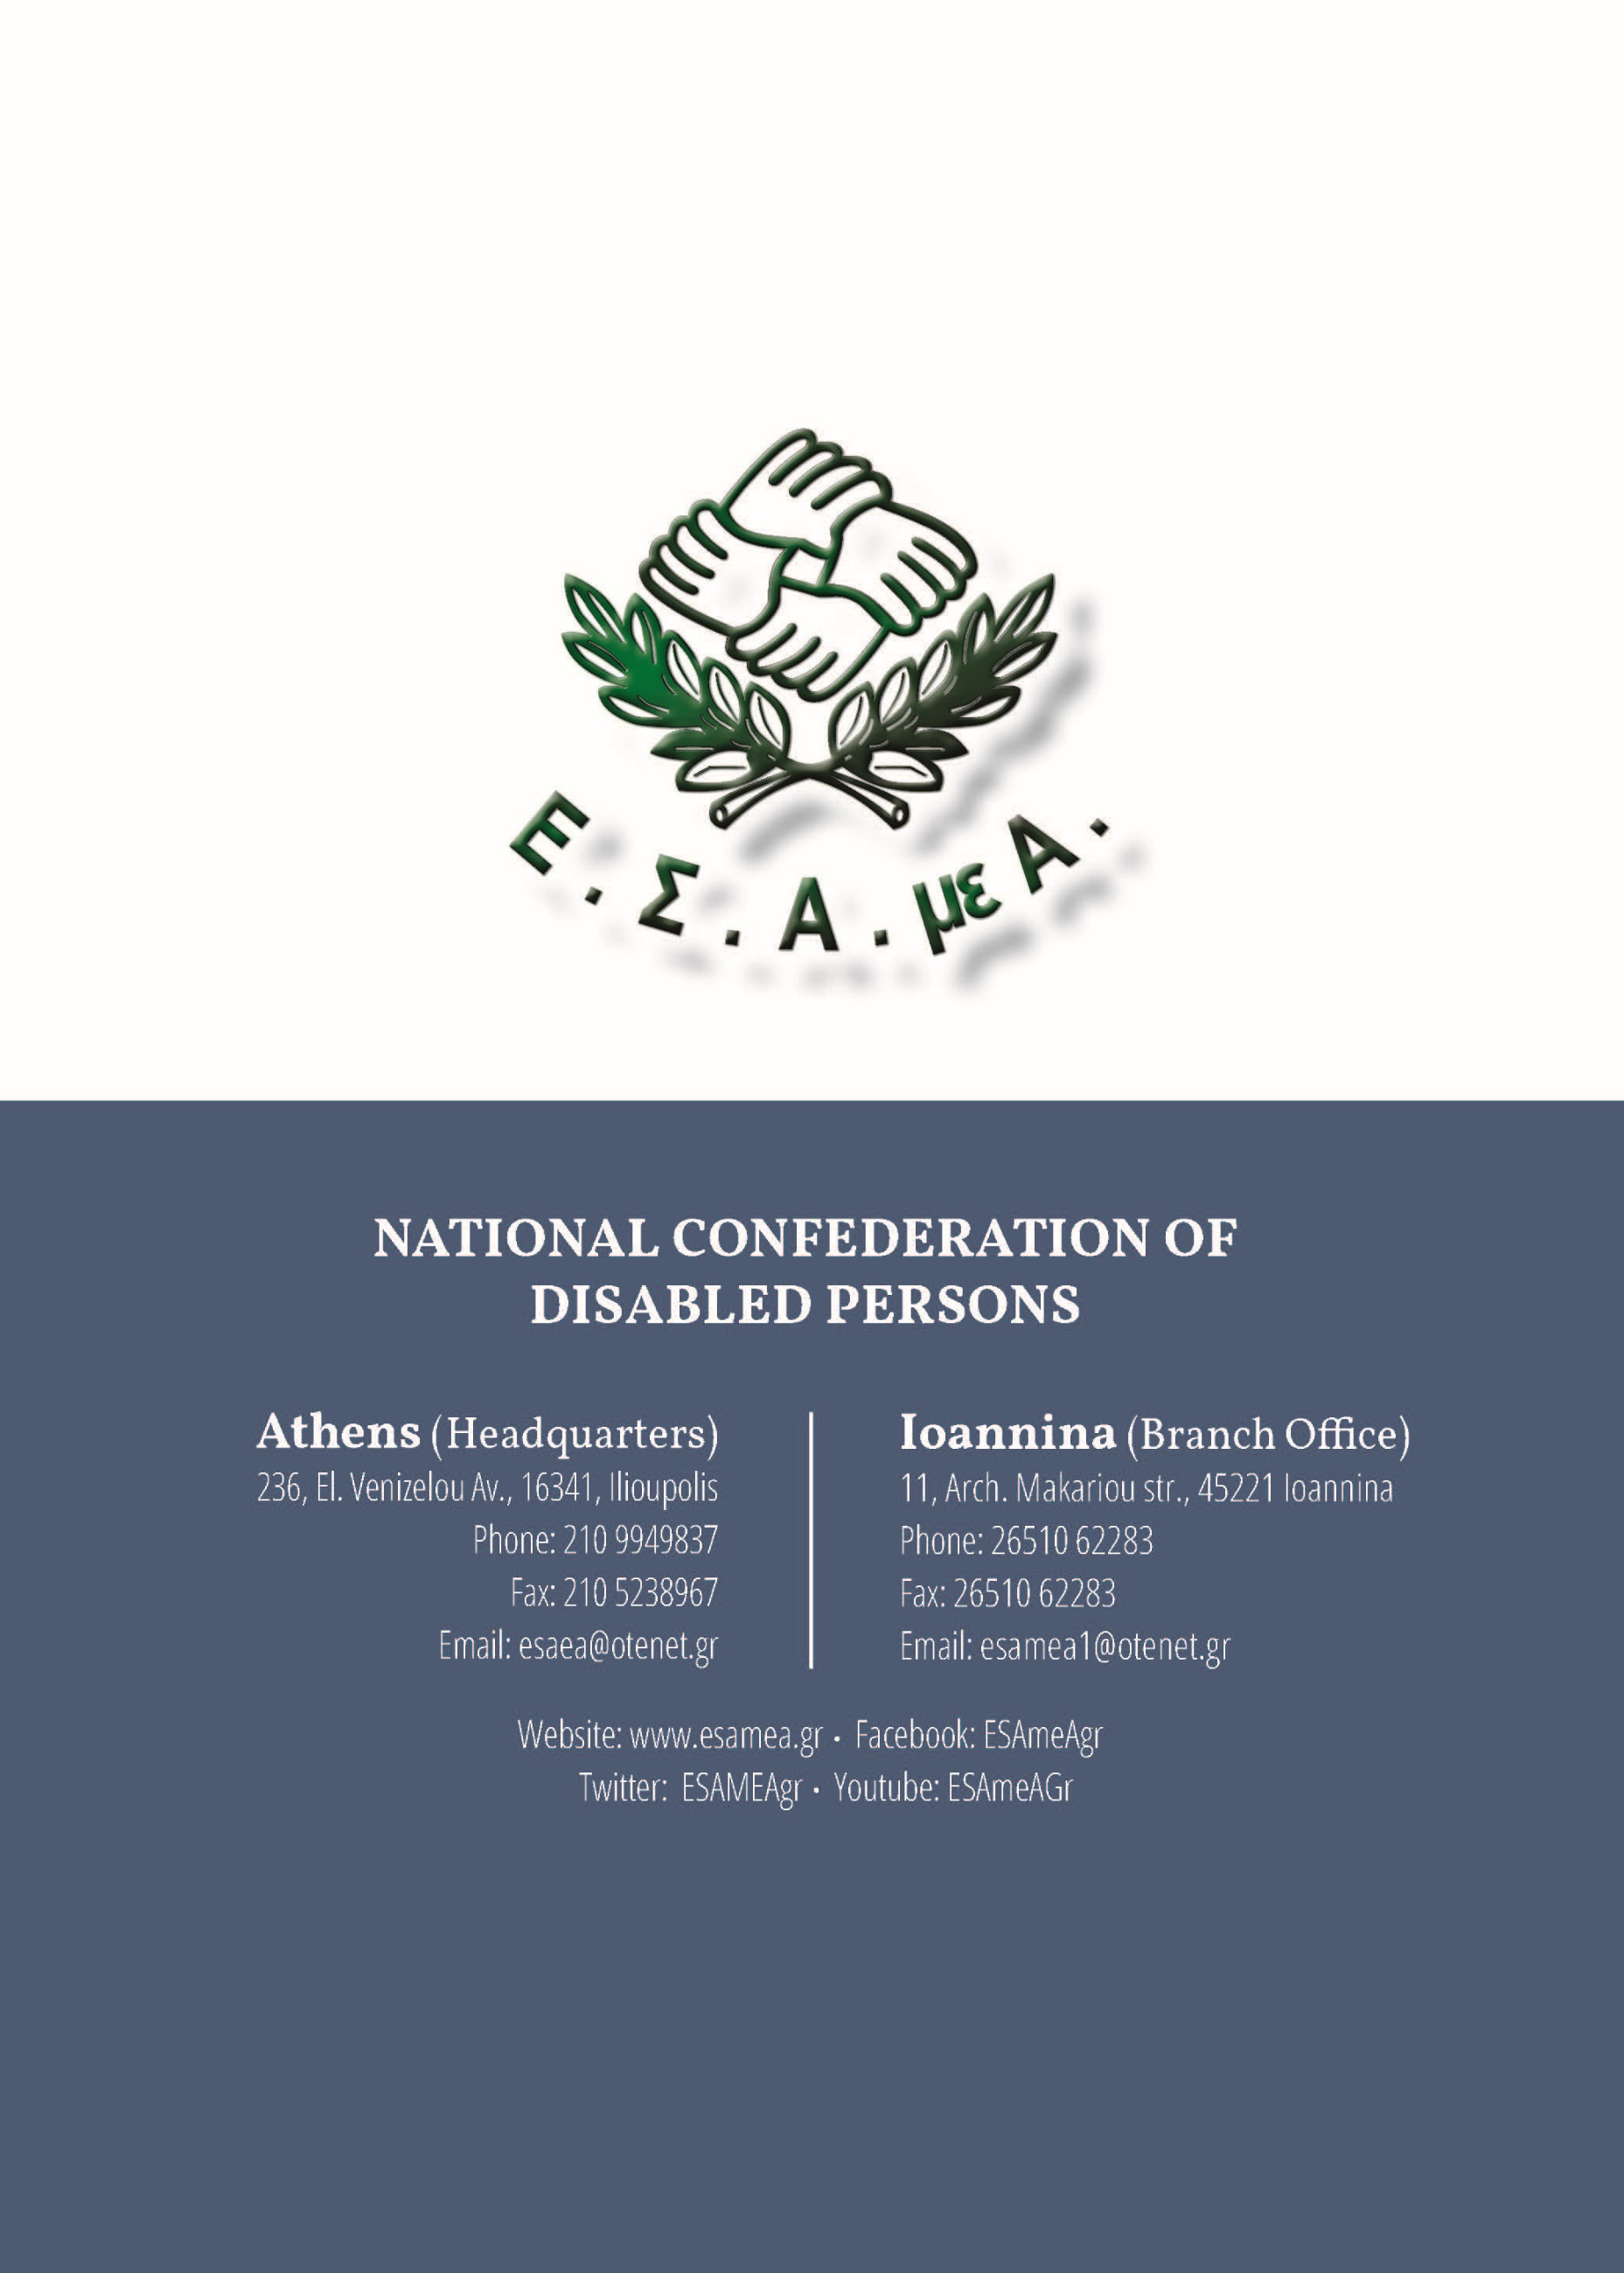**National Confederation of Disabled Persons (NCDP)**

Athens (Headquarters)

236, El. Venizelou Av., 16341, Ilioupolis

Phone: 0030 210 9949837

Fax: 0030 210 5238967

Email: esaea@otenet.gr

Ioannina (Branch Office)

11, Arch. Makariou str., 45221 Ioannina

Phone: 0030 26510 62283

Fax: 0030 26510 62283

Email: [esamea1@otenet.gr](mailto:esamea1@otenet.gr)

Website: [www.esamea.gr](http://www.esamea.gr)

Facebook: ESAmeAgr

Twitter: ESAMEAgr

Youtube: ESAmeAGr