[Logo] 4PLUS project,
Interreg IPA II CBC
Greece–Albania Programme 

Preparedness Guide for persons with disability

Make your own plan

**One natural hazard may affect your life too**

|  |  |  |  |
| --- | --- | --- | --- |
|  |  |  |  |
| EARTHQUAKE | FIRE | FLOOD | EXTREME CONDITIONS |

The 4PLUS project is co-funded by the European Union and National Funds of the countries  
participating in the Interreg IPA Cross-Border Cooperation Programme “Greece-Albania 2014-2020”

**National Confederation of Disabled Persons (NCDP)**

Headquarters: 236 El. Venizelou str., P.C. 163 41, Ilioupoli

Phone: +30 210 9949837, Fax: +30 210 5238967

E-mail: esaea@otenet.gr, Website: www.esamea.gr

② The page of NCDP in Facebook: <https://el-gr.facebook.com/ESAmeAgr>

① Follow NCDP on Twitter: <https://twitter.com/ESAMEAgr>

 Find the NCDP channel on YouTube: [www.youtube.com/user/ESAmeAGr](https://www.youtube.com/user/ESAmeAGr)

Athens, 2021

This guide was prepared for the NCDP from the company EUROPRAXIS m.IKE. in the framework of the project “4PLUS: Public awareness, Preparedness, Participation and Coordination for Civil Protection for All”. The project is part of the “Interreg IPA II Cross-Border Cooperation Program Greece-Albania 2014-2020” (greece-albania.eu) and is co-financed by the European Union and by national funds of Greece and Albania. The views expressed in the guide do not necessarily reflect the views of the European Union, the participating countries, and the Managing Authority.

Press editing and production of  
alternative accessible formats:

**EUROPRAXIS μ.ΙΚΕ**

4 Vergas str., P.C. 176 73 Kalithea

Phone: +30 210 9521313, Fax: +30 210 9521318

Email: [info@euro-praxis.com](mailto:info@euro-praxis.com), Website: www.euro-praxis.com

# Why should you prepare?

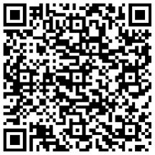Large-scale natural disasters such as fires, extreme weather, floods and earthquakes are largely unpredictable and endanger many aspects of people's lives - health, safety, housing, access to food, water and more staple items, to name just a few.

[L](https://portal.4plus-project.eu/el/citizens/citizens-disabilities/3/giati-einai-shmantiko-na-kaneis-to-diko-soy-sxedio-kai-na-proetoimasteis)

The issue of preparedness is a shared responsibility. It concerns all of us. It clearly concerns the readiness of state mechanisms and operational teams, but it also **concerns the readiness of the individuals themselves and their families**. It also concerns the readiness of friends, the neighborhood and the entire population in general, given that at some point everyone can find themselves in the position of being the only one nearby who can help.

Recognizing the importance of citizen preparedness, the state and civil protection agencies from time to time try in various ways and means to raise awareness and inform the general population. But, especially for the protection of people with disabilities and/or chronic conditions, the issue of preparedness needs increased attention and requires advance **planning** and **personalization**. By taking a few simple, yet targeted, steps today, each of us can be better prepared to face a range of emergencies.

This Guide is intended to help you start your preparation, focus on the important issues and better protect yourself and your loved ones.

**Note**: It was practically impossible to fit all the information and advice we have gathered for you in this short publication. But as you'll see, the Guide makes extensive use of *Quick Response (QR) Codes*, which act as barcodes that can be scanned with your device's camera to quickly access web addresses without having to type or remember the address. That way, by scanning the QR code for example next to a section of this Guide, and as long as your device has access to the Internet (e.g. connected to Wi-Fi or using mobile data), it will automatically open on your device the corresponding website (from the website [www.portal.4plus-project.eu](http://www.portal.4plus-project.eu)) where more detailed information/instructions are offered. We hope you enjoy reading this book!

# What should you think about?

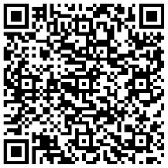Where will you, your loved ones or caregivers be when a threat or emergency occurs? You could be anywhere – at home, at work, on some form of transport. Disasters can strike instantly and without warning and can force you to evacuate or confine you to your home. Rescuers and emergency personnel will look for those who need help after a disaster, but they cannot reach everyone at once. Are you ready to stay protected in your space for as long as necessary? Which of your relatives will you communicate with and how? What will you do if basic services – water, heating, electricity, communications, or transport – are interrupted? How will you evacuate your space safely and successfully? What will you do and where will you go after evacuation? These questions are indicative, and it is especially important to have the answers to the questions ready in advance so that you and the people who can help you are not surprised when the time comes. You will be able to deal with a threat much more effectively if you and those around you invest time in your preparedness.

[L](https://portal.4plus-project.eu/el/citizens/citizens-disabilities/4/to-diko-soy-sxedio-des-ti-oa-prepei-na-skefteis)

We invite you to read the content of this Guide, but also to share this information with your relatives, so that in case of any emergency, you know exactly how to act and where to turn. Because the State must take its measures, but for better results, we citizens must also take care of our self-protection.

# What will you need to do in advance?

To prepare your own plan (and to keep it constantly up to date), we recommend **nine steps** with specific instructions and advice to those with disabilities (people with disabilities and/or chronic conditions, senior citizens, etc.), so that know what you will need to do in advance to maximize your preparedness levels.

1. Get informed
2. Do your own self-assessment
3. Take precautions
4. Build your own network
5. Plan
6. Mange your stock and supplies 
7. Participate
8. Practice
9. Keep it up

## Get informed

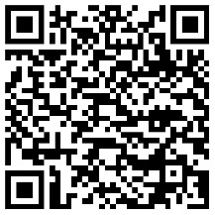First, you should inform yourself, recognize and understand the potential risks and gather information about your protection.

* Find out which disasters could happen in your **area** and inform about their **typology** and possible **seasonality**.
* Find out what are the **local emergency plans** and **emergency assistance programs** of your municipality and other competent bodies in your area.
* Find out if there are **facility evacuation plans** in the areas where you live, work and frequent.
* Search and record the **accessible routes** that you can use in case of emergency evacuation/movement.
* Contact local transportation providers to list your **accessible transportation options**.
* Look for information on appropriate **precautions**, general **instructions** and **special instructions for people with disabilities**.
* Look for **useful telephone numbers** and other **sources of information** for emergencies.

So, remember, as unpleasant as it sounds, in the case of disasters, the saying applies: **Ignorance kills, knowledge saves lives!**

## Do your own self-assessment

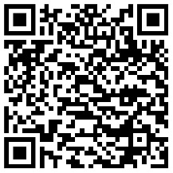Your next step is your **personal assessment** to determine the **risks** specific to you, your **degree of independence** and your **vulnerabilities**. You and your loved ones are in the best position to know the characteristics of your space and any obstacles around you, your functional abilities, and possible needs for extra help during and after an emergency or disaster situation. You should assess the situation and judge what you will be able to do for yourself and what help you may need before, during and after a disaster, taking into account the likely post-disaster conditions, your capabilities and new limitations that may arise due to the effects of the phenomenon.

## Take precautions

Based on the findings of the assessment, you should take the first **precautionary measures** to limit your vulnerabilities, for example against earthquake, fire, flood, frost and heavy snowfall. Also, you should take measures for the autonomy of your communications and equipment.

## Build your own network

You should start by building your **personal support network** with everyone who can help you both prepare for emergencies and deal with them effectively.

## Plan

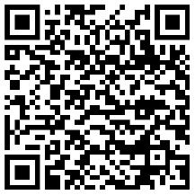Now, you have gathered all the necessary information and people you need to create your **personal (or family) plan** for each hazard (earthquake, flood, forest fire, severe weather, etc.). Keep in mind that the emergency experience can be intense, and stress can make certain medical conditions worse. Your preparation also has this role: If the need arises, to feel strong and confident thanks to your good preparation!

Depending on the type of disaster you may need to decide whether to stay where you are or leave (evacuate). Plan for your **early warning**, for the case of **temporary refuge on the spot** and for the case of **immediate evacuation** of the area you are in.

Also, plan in advance for your **communications** in case of emergency and see what advice we give by category of disability.

## Manage your stock and supplies

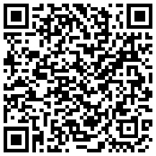In the event of a disaster, could you and your family manage on your own for several days? After or during a disaster you may not have access to essential items, services, medicines, etc.

The general directive, according to the General Secretariat of Civil Protection, all citizens should for their part be ready to fend for themselves in their space for at least the first **72 hours (three days)** of an emergency - that is, as long as businesses can focus on those in urgent need. It is also recommended that you have a **week**'s worth of any pharmaceutical/medical supplies. On a global level, it is **ideally** recommended that all citizens be additionally prepared to cope with **two full weeks** of confinement/isolation at home, a need that has been confirmed recently with the spread of the new coronavirus pandemic.

So, you should take care **in advance** for the following:

1. ensure that you have in your premises (home, office, etc.) some **basic survival supplies** in the event of confinement, isolation (quarantine) or shelter-in-place (if this is the instruction of the authorities), and
2. prepare an **emergency backpack** with the basics, which you will have at your place so that you can easily and quickly take it with you in the event of immediate evacuation.

## Participate

Take part in initiatives of your municipality, of voluntary organizations by your place, etc. related to civil protection.

## Practice

The drills will help build your confidence and ease any insecurities you may have about dealing with the emergency and help keep you calm in the event of an actual event.

## Keep it up

In order for all your efforts in the previous steps to make sense, you should plan for the maintenance of your Plan and all its elements in the long term!

# At the time of the hazard

When something happens without warning, it's important to take a few seconds to think about what your next steps should be. This includes determining what type of incident occurred and whether there is immediate danger, such as damaged buildings or downed power lines. The goal is to stay safe and away from the dangers that have arisen.

Learn what you should pay attention to at that time, what to do during the temporary shelter in your place and what to do during the emergency evacuation. Learn what to look out for after evacuation and what to do if you find yourself in a temporary shelter/camp.

|  |
| --- |
| How can the rest of us help  a person with a disability  at the time of the threat? |

# Back to normal

Recovering from a disaster can be a slow, difficult, and stressful process. Your personal safety and peace of mind should be your primary concern, as the emotional cost of a disaster can sometimes be even more devastating than any financial losses.

# Complete your readiness in 12 months

**Month 1**: Find out about the risks and emergency plans in your area. Make your personal assessment.

**Month 2**: Find ways to make your spaces even safer and plan the various interventions. Start building your Personal Support Network.

**Month 3**: Start preparing a plan adapted to your situation for all types of risk and for all phases and issues of an emergency (warning, shelter in place, evacuation, communication, receiving emergency services, recovery, etc.).

**Month 4**: Gather/organize emergency supplies/backpack.

**Month 5**: Organize and protect your important documents.

**Month 6**: Build up your financial savings and keep them in safe places (not all together in the same place).

**Month 7**: Subscribe to relevant services, directories, and registries for emergency assistance. Take part in actions of the community and voluntary organizations in your area.

**Month 8**: Rehearse the evacuation and shelter-in-place plan. Organize/participate in a preparedness exercise. Familiarize yourself with precautions during various threat typologies.

**Month 9**: Rehearse the emergency communication plan with everyone involved.

**Month 10**: Make sure everyone in your household knows where to go after different types of disasters. Visit and familiarize yourself with the premises.

**Month 11**: Sign up for CPR and first aid training, as well as other special hazard training offered in your area or online.

**Month 12**: Take care of life and property insurance against possible disasters or other related coverage.

|  |
| --- |
| Information about the emergency number 112  Emergency line. Find out what it can offer you, and what provisions exist for notification and communication with disabled people. |

If you face an emergency anywhere in Greece or the rest of the European Union[1] all you need to remember is one number, 112 (European emergency number[2]). Line 112 refers to the Emergency Information Service and is used, a comprehensive emergency communications service, which operates 24 hours a day, 7 days a week and includes an **inbound** and **outbound** service.

**Booklet (Greek)**: [](https://www.civilprotection.gr/sites/default/gscp_uploads/112leaflet2021_gr.pdf) **Version for kids**: [](https://www.civilprotection.gr/sites/default/gscp_uploads/112_information_kids_2021_1.pdf)

The 112 system allows the citizen to notify the emergency services not only by phone call, but also:

* by sending SMS and MMS messages (to **112**)
* by sending an email (at [**contact@112.gov.gr**](mailto:contact@112.gov.gr))
* by sending a fax (to the number **11 112**)
* through the **gov.gr application**, which is available free of charge for mobile phones with **iOS** or **Android**.

[**iOS**](https://apps.apple.com/gr/app/gov-gr/id1525960171): [](https://apps.apple.com/gr/app/gov-gr/id1525960171) [**Android**](https://play.google.com/store/apps/details?id=com.govgrvault): [](https://play.google.com/store/apps/details?id=com.govgrvault)

|  |  |  |  |
| --- | --- | --- | --- |
| [**Online registration to Service 112**](https://112.gr/el-gr/)**:** | **<https://112.gr/el-gr/>** | [**Device settings for receiving Cell Broadcast messages**](https://www.civilprotection.gr/el/cellbroadcasting)**:** | **<https://www.civilprotection.gr/el/cellbroadcasting>** |

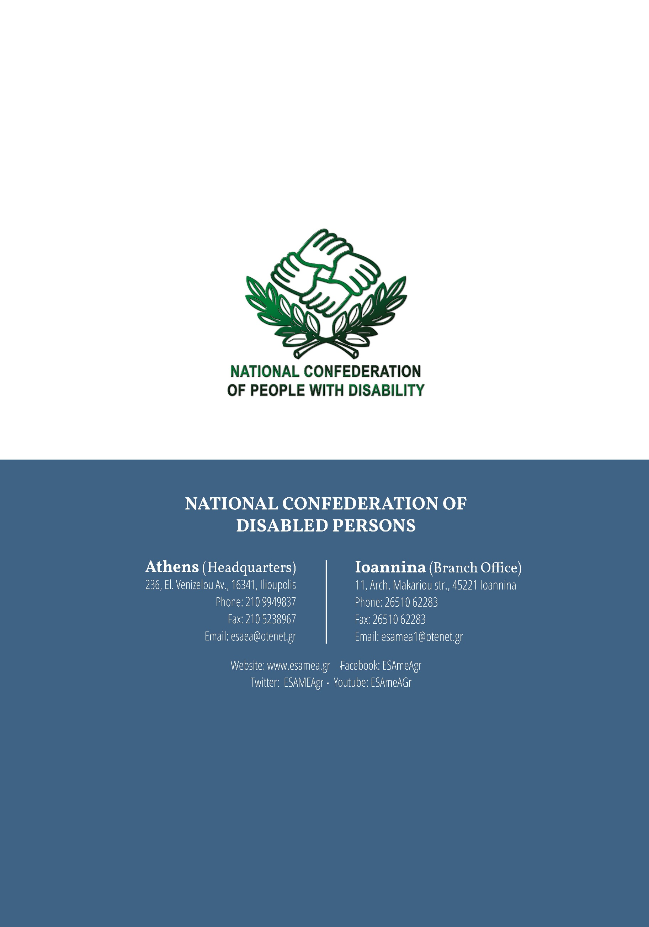**NATIONAL CONFEDERATION OF DISABLED PERSONS**

**Athens (headquarters)**

236, El. Venizelou Av., 16341, Ilioupolis

Phone: 210 9949837

Fax: 210 5238967

Email: esaea@otenet.gr

**Ioannina (Branch office)**

11, Arch. Makariou str., 45221 Ioannina

Phone: 26510 62283

Fax: 26510 62283

Email: esamea1@otenet.gr

Website: [www.esamea.gr](http://www.esamea.gr)

Facebook: ESAmeAgr

Twitter: ESAMEAgr

Youtube: ESAmeAGr

1. Note: Also used in Switzerland and South Africa.
2. 112 works in all EU Member States alongside the national emergency numbers. In some EU countries, as in our country, it is the only emergency number.